- GIT commands execution
  - $ git init → created a .git file
  - $ git --version

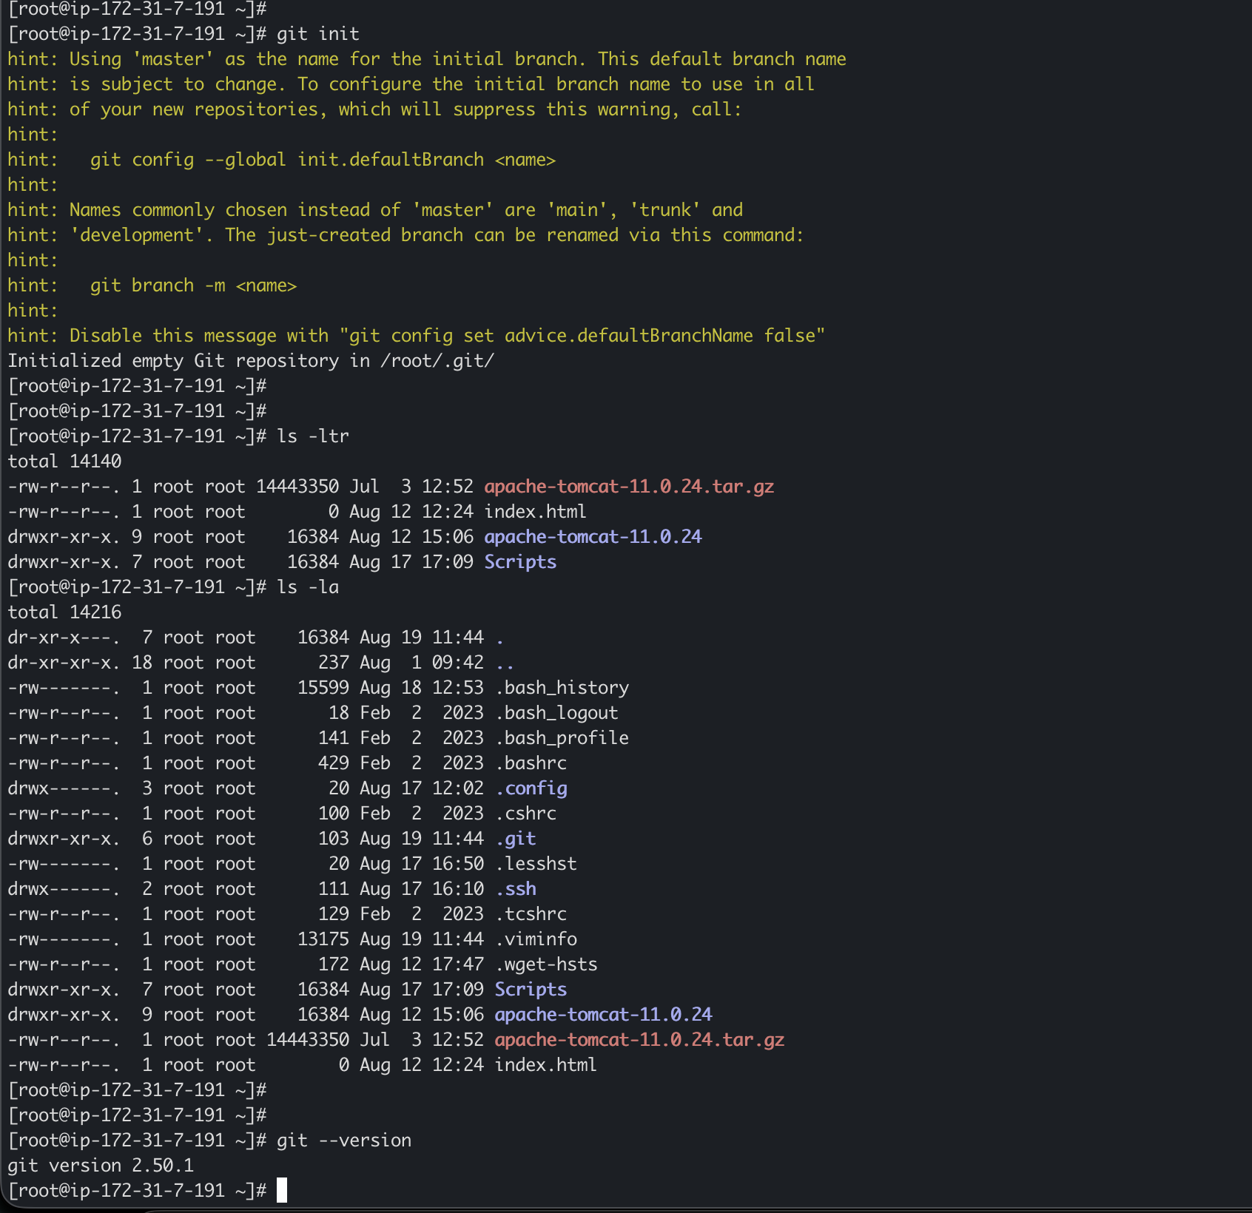

  - $ git config --list
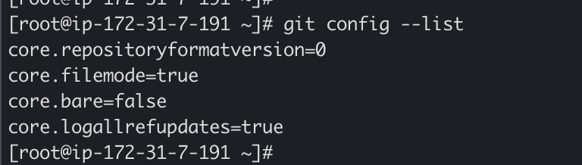

  - $ git config --global user.name “nayeem”
  - $ git config --global user.email “nayeemluvs@gmail.com
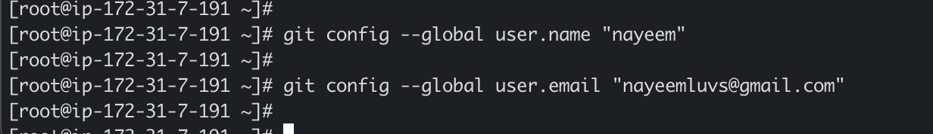

  - $ git status → Check the status of the changes made
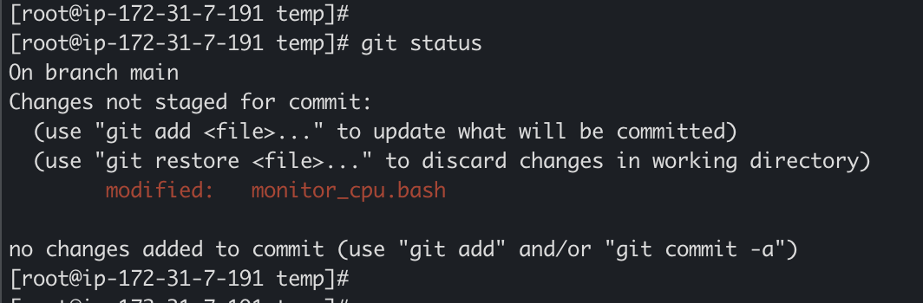

  - $ git add . → To add the changes to staged
  - $ git log → To track all changes made in git
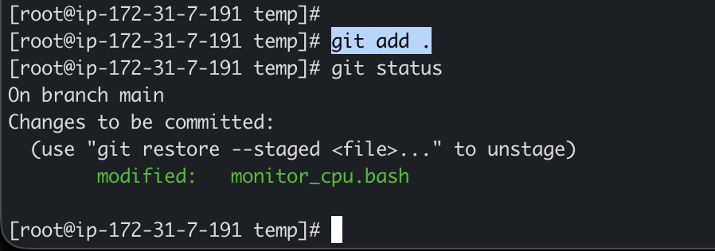

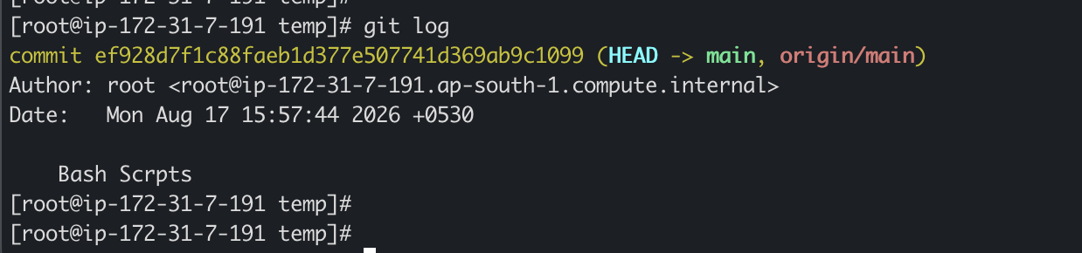

  - $ git commit -m “First commit”
  - $ git log → To track all changes made in git
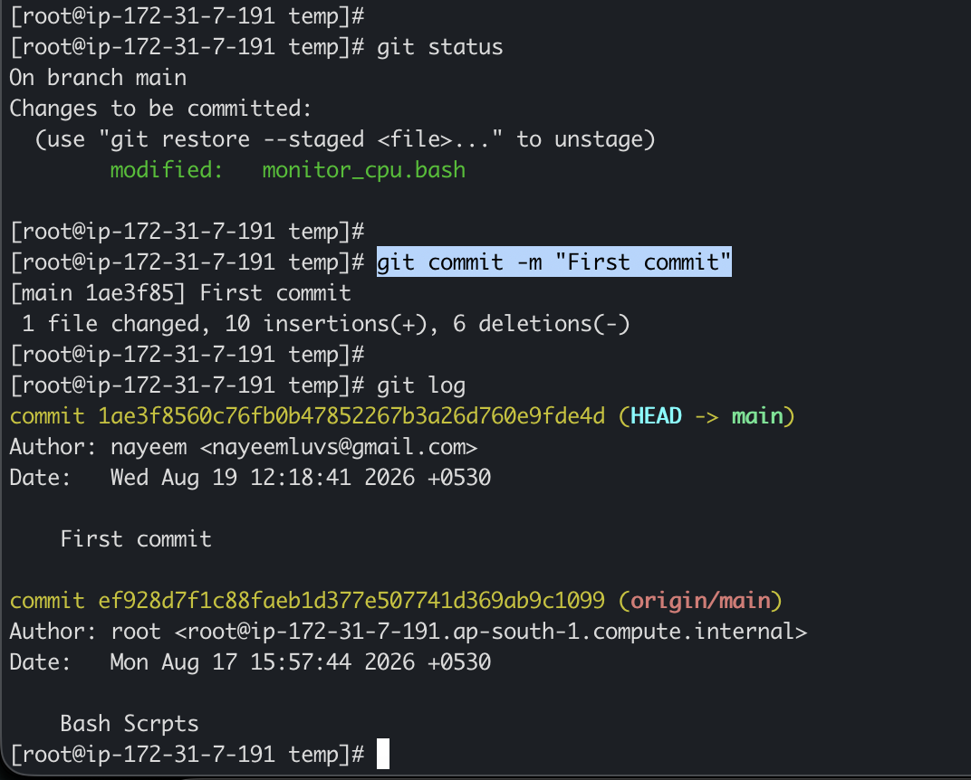

  - $ git remote -v → check which remote repository your local Git repository is connected to
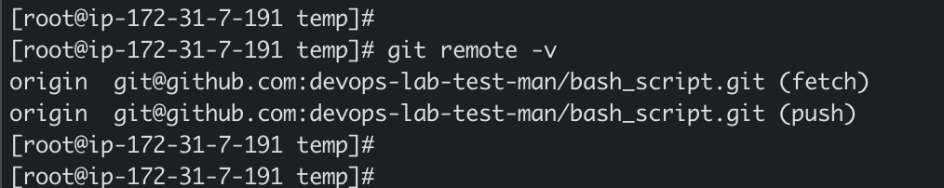
  - $ git remote add origin git@github.com:devops-lab-test-man/bash_script.git
→ Configure the remote repository URL
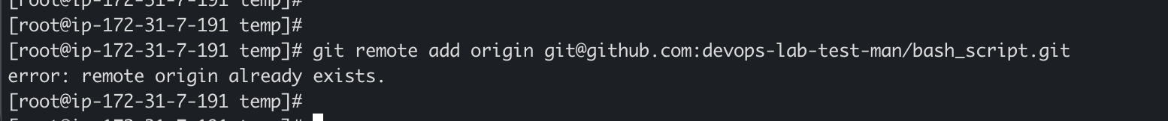
  - $ git remote set-url origin git@github.com:devops-lab-test-man/bash_script.git
→ changes the existing URL of the origin remote.
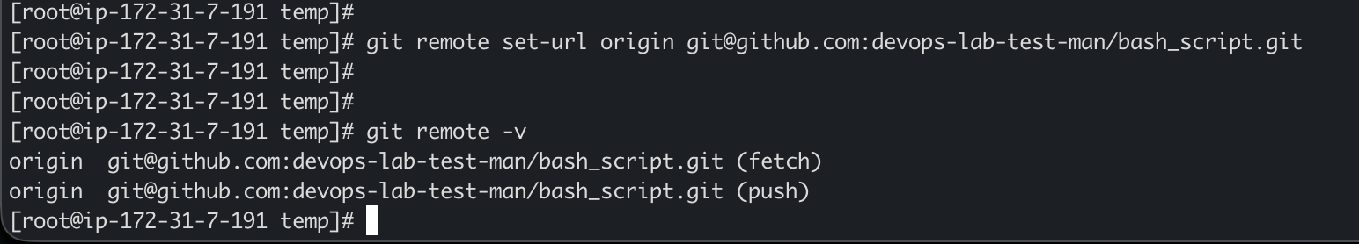
  - $ ssh-keygen
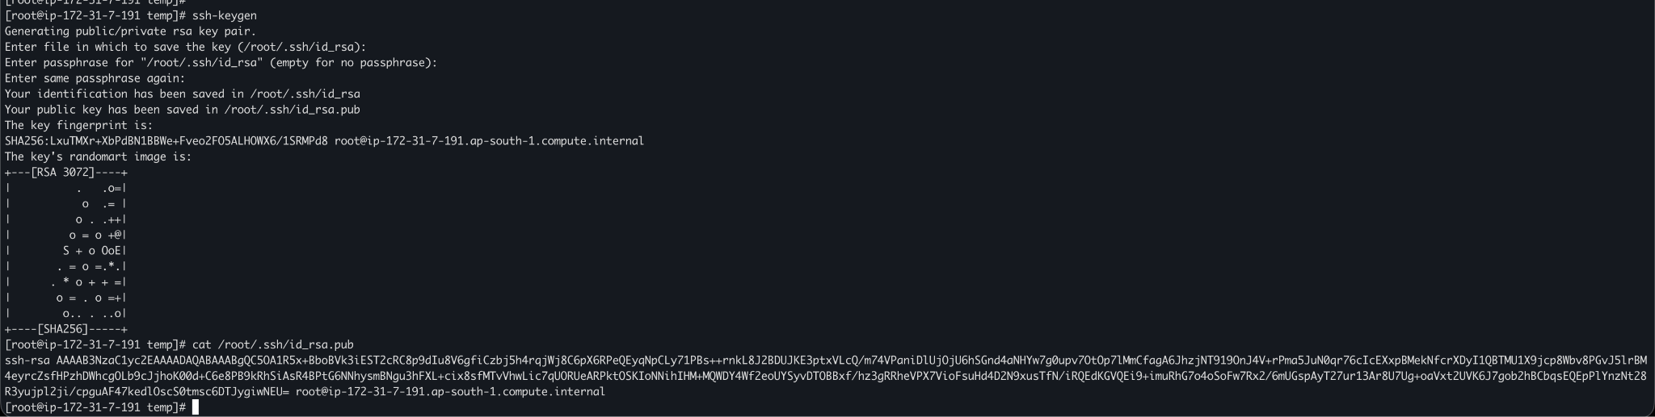

  - Configuring ssh key in GitHub
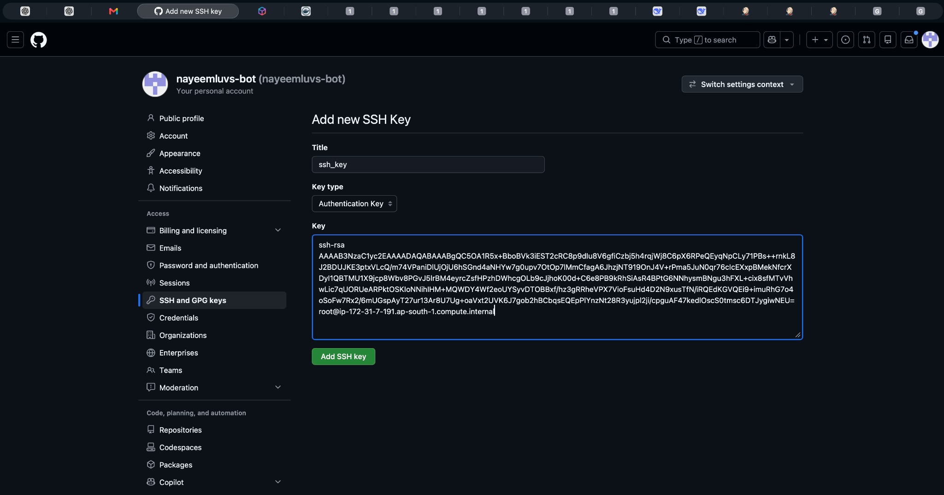

  - $ git push origin main
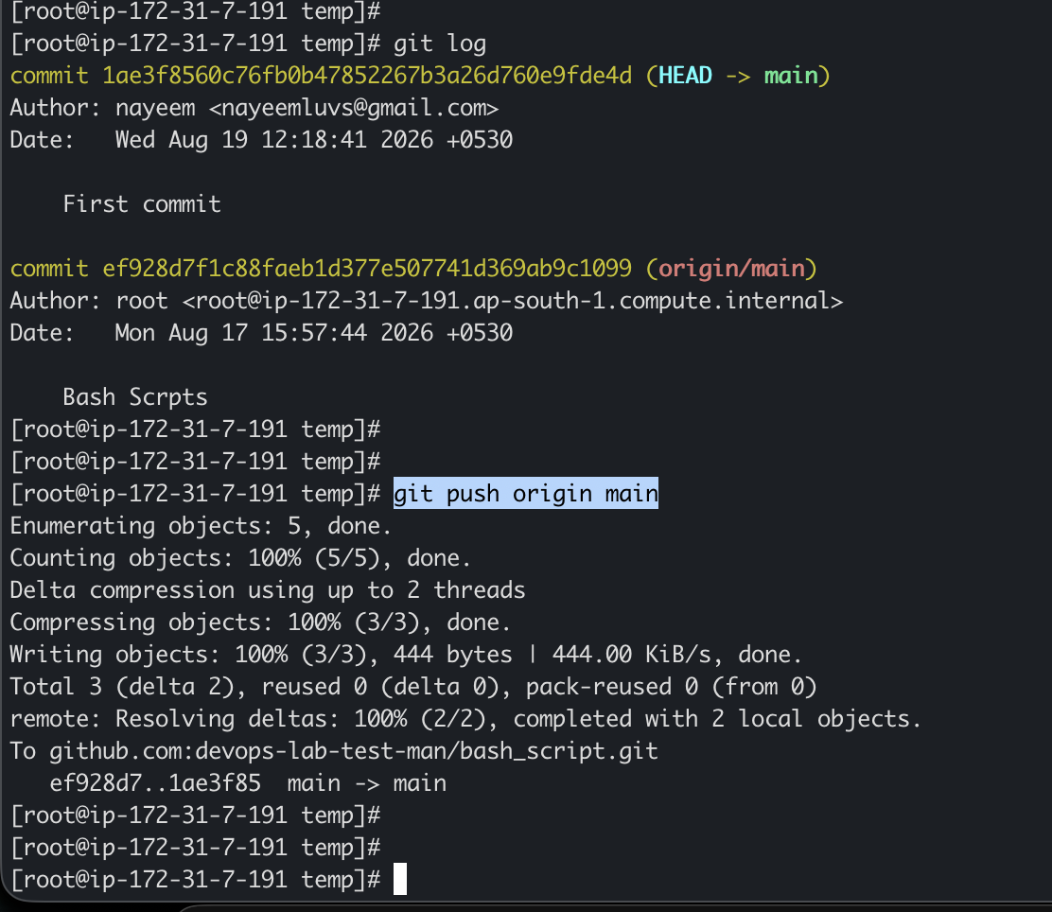
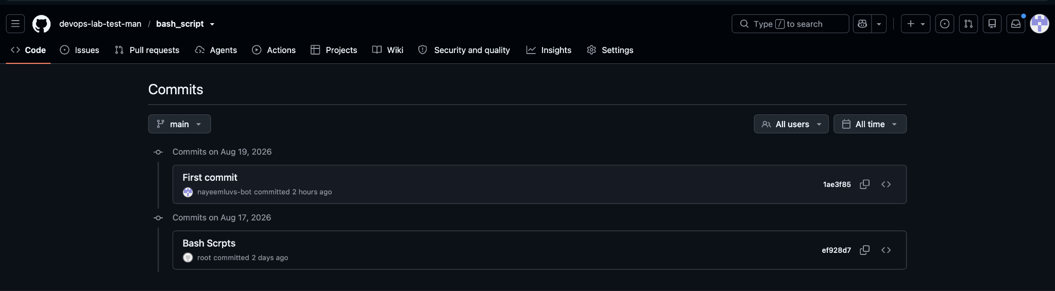

  - $ git branch -m master main → Renames the local branch
  - $ git push origin --delete master → Delete old master branch
  - $ git branch → Check your branch

